Project Title:
Intelligent meeting notes and summarizer (Intelligent Meeting Companion)

Name – Shilpy Suman
Course/batch - B. Tech (ECE), 2023-27
Institute name – Institute of engineering and management, Kolkata

Project Guide: Dr Chandan Biswas

Period of Internship: 18th May 2026 – 31st July 2026

Report submitted to: IDEAS – Institute of Data Engineering, Analytics and Science Foundation, ISI Kolkata

- Abstract
The Intelligent Meeting Companion is an AI-powered web application designed to automate the process of meeting documentation by converting spoken discussions into structured meeting notes. The system captures meeting audio through a web interface and a Chrome extension, processes the audio using a Fast API backend, and utilizes Google's Gemini AI model to generate concise meeting summaries, key discussion points, and actionable tasks.
The application is deployed on AWS, allowing users to access it remotely through a web browser. The Chrome extension further enhances usability by enabling users to capture meeting audio directly from platforms such as Google Meet and Zoom. The system eliminates the need for manual note-taking, improves productivity, and provides accurate AI-generated meeting documentation in real time

- Introduction
During the internship, I gained practical knowledge in several technologies that were directly applied in the development of the Intelligent Meeting Companion. The major topics used in this project include GitHub for version control, Cloud Computing (AWS) for deployment, Large Language Models (LLMs) for AI-powered text generation, Agentic AI for intelligent meeting analysis, and Data Science Application Development for building the complete web application.
The Intelligent Meeting Companion is an AI-based application that automatically converts meeting audio into structured meeting notes. The system captures meeting audio through a web application and Chrome extension, processes it using a Fast API backend, and utilizes Google's Gemini AI model to generate meeting summaries, key discussion points, and action items.
The application has been successfully deployed on AWS, enabling remote access through a web browser. The Chrome extension allows users to capture meeting audio directly from platforms such as Google Meet and Zoom. The project demonstrates the practical application of cloud computing, backend development, AI integration, and web technologies to solve the problem of manual meeting documentation.

- Project Objective
The main objectives of the Intelligent Meeting Companion project are:
- To develop an AI-powered application that automatically generates meeting summaries from recorded meeting audio.
- To reduce manual note-taking by identifying key discussion points and action items using Google Gemini AI.
- To capture and process meeting audio efficiently through a web application and Chrome extension integrated with platforms such as Google Meet and Zoom.
- To build a scalable client-server architecture using Fast API for backend processing and deploy the application on AWS for remote accessibility.
- To demonstrate the practical application of Large Language Models (LLMs), cloud computing, and modern web technologies in developing an intelligent meeting assistant.
Hypothesis Testing: Not applicable.
Sample Survey: No survey was conducted as part of this project.

- Methodology
The Intelligent Meeting Companion was developed using a client-server architecture consisting of a web application, a Chrome extension, a Fast API backend, and Google Gemini AI.
- Designed the system architecture and identified the required modules: frontend, extension, backend, and AI processing.
- Developed the frontend using HTML, CSS, and JavaScript to provide recording controls and display generated meeting notes.
- Built a Chrome extension to capture meeting audio directly from platforms such as Google Meet and Zoom.
- Captured audio using the Web Audio API, converted it into 16 kHz mono PCM format, and sent it to the backend in small chunks.
- Implemented the backend using Python Fast API to receive audio chunks, combine them into a WAV file, and process the recording.
- Integrated the Google Gemini API to generate the meeting summary, key discussion points, and action items from the recorded audio.
- Deployed the application on AWS and managed the source code using GitHub.
Git hub repository - https://github.com/shilpy2088-s/IntelligentMeetingNotesAndSummarizers

- Data Analysis and Results

The Intelligent Meeting Companion was successfully tested for all major functionalities, including audio recording, Chrome extension integration, backend processing, AI-generated meeting note creation, and AWS deployment. The application accurately captured meeting audio, processed it through the Fast API backend, and generated structured meeting summaries, key discussion points, and action items using the Google Gemini AI model. Functional testing confirmed that all modules operated as expected, and the deployed application was accessible through the web. As the project uses a pre-trained Gemini AI model, no hypothesis testing, statistical analysis, or machine learning model comparison was performed. Relevant screenshots of the application interface, Chrome extension, generated meeting notes, AWS deployment, and GitHub repository are included to illustrate the project results.
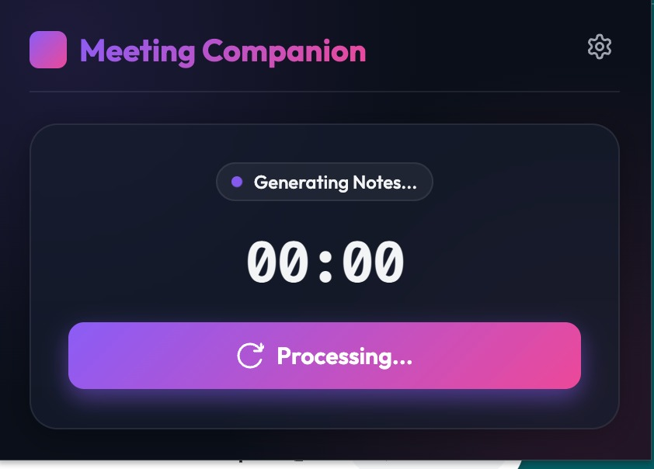
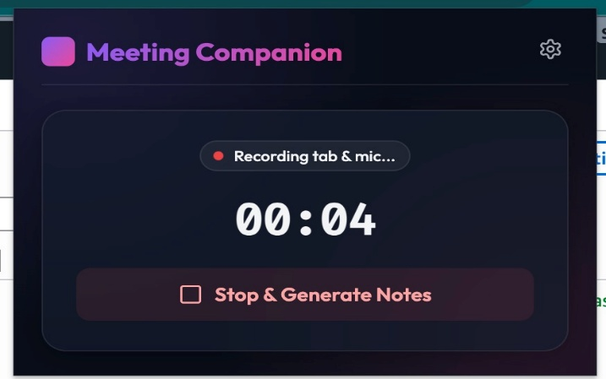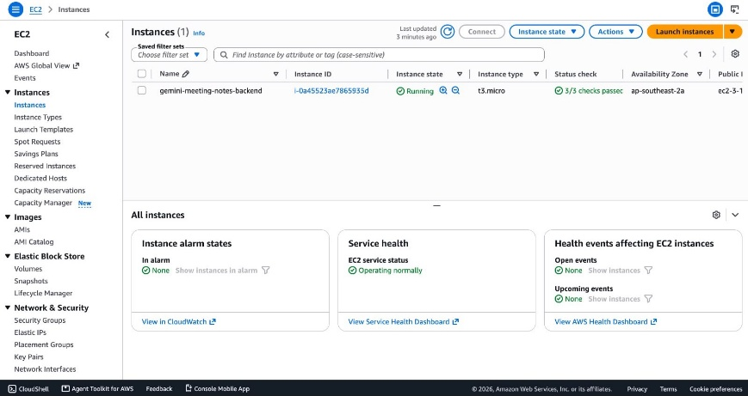

- Conclusion
The Intelligent Meeting Companion was successfully developed and deployed to automate meeting documentation using Artificial Intelligence. The application captures meeting audio through a web application and Chrome extension, processes it using a Fast API backend, and generates meeting summaries, key discussion points, and action items using Google Gemini AI. The successful AWS deployment and functional testing confirmed that all major modules worked as expected. The project demonstrates the practical use of AI, cloud computing, and web technologies in improving meeting productivity and reducing manual note-taking.
Recommendations for Future Work
- Add support for multiple languages.
- Implement speaker identification for multi-participant meetings.
- Enable export of meeting notes in PDF and DOCX formats.
- Improve the user interface with additional customization options.
- Integrate with more online meeting platforms and calendar services.

- APPENDICES
Appendix A: References
The following resources were referred to during the development of the project:
- Google Gemini API Documentation
- Fast API Official Documentation
- Python Official Documentation
- HTML, CSS, and JavaScript Documentation (MDN Web Docs)
- AWS Documentation
- GitHub Documentation

Appendix B: Survey Questionnaire
Not Applicable. No survey was conducted for this project.
Appendix D: Project Documents
The following project documents are available in the GitHub repository:
- Internship Project Report
- Project Presentation (PPT)
- Source Code
- System Architecture Diagram
- Application Screenshots

